**Appendix Documents.**

***No.1 - Introduction of BOAS Conference.***



***No.2 - Method of examination and grading system for BOAS***



***No.3 – Nostril opening examples***



***No.4 - Boas Anatomy***

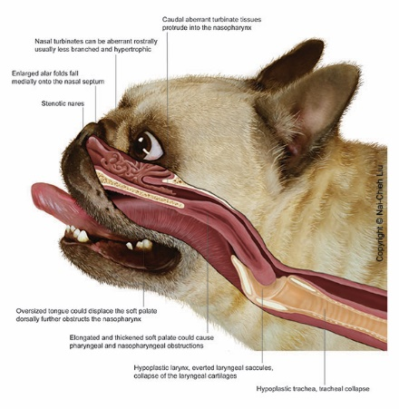

***No.5 - Boxer***



***No. 6 –*** *BRACHYCEPHALIC BREEDS AND BRACHYCEPHALIC OBSTRUCTIVE AIRWAY SYNDROME (BOAS) FCI - Report, Strategy and Recommendations*



***No. 6 -*** *Population of Pedigree Dogs and the Consequences of Breed-specific Legislation*



***No.7 _ Nordic Kennel Clubs***



**Useful links**

Cambridge University Veterinary Web Site – Boas

<https://www.vet.cam.ac.uk/boas/about-boas>

The Royal Kennel Club - - Brachycephalic obstructive airway syndrome

<https://www.thekennelclub.org.uk/health-and-dog-care/health/health-and-care/a-z-of-health-and-care-issues/breathing-problems-brachycephalic-dogs/>

**FCI – Video Discussion about BOAS**

<https://youtu.be/gB8fckCv-tU>